Page 2:

world happiness map: <http://www.highcharts.com/maps/demo/rich-info>

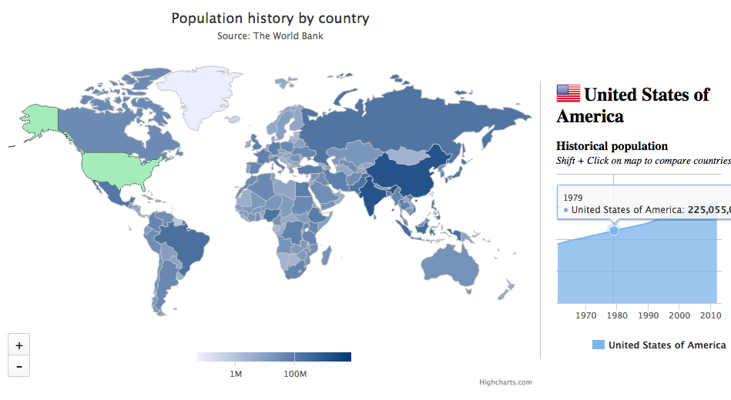

input:

\*if we have 15min data, then the time scale will divide to 15, and we need a calculated value for each minute

? ("ï»¿\"Data Source\",\"World Development Indicators\",\

n\ "Country Name\",\"Country Code\",\"Indicator Name\",\"Indicator Code\",\ "1961\",\"1962\",\"1963\",\"1964\",\"1965\",\"1966\",\"1967\",\"1968\",\"1969\",\"1970\",\"1971\",\"1972\",\"1973\",\"1974\",\"1975\",\"1976\",\"1977\",\"1978\",\"1979\",\"1980\",\"1981\",\"1982\",\"1983\",\"1984\",\"1985\",\"1986\",\"1987\",\"1988\",\"1989\",\"1990\",\"1991\",\"1992\",\"1993\",\"1994\",\"1995\",\"1996\",\"1997\",\"1998\",\"1999\",\"2000\",\"2001\",\"2002\",\"2003\",\"2004\",\"2005\",\"2006\",\"2007\",\"2008\",\"2009\",\"2010\",\"2011\",\"2012\",\"2013\",\

(input data start here)

n\ "Aruba\",\"ABW\",\

"Population (Total)\",\

"SP.POP.TOTL\",\

"55435\",\"56226\",\"56697\",\"57029\",\"57360\",\"57712\",\"58049\",\"58385\",\"58724\",\"59065\",\"59438\",\"59849\",\"60239\",\"60525\",\"60655\",\"60589\",\"60366\",\"60106\",\"59978\",\"60096\",\"60567\",\"61344\",\"62204\",\"62831\",\"63028\",\"62644\",\"61835\",\"61077\",\"61032\",\"62148\",\"64623\",\"68235\",\"72498\",\"76700\",\"80326\",\"83195\",\"85447\",\"87276\",\"89004\",\"90858\",\"92894\",\"94995\",\"97015\",\"98742\",\"100031\",\"100830\",\"101219\",\"101344\",\"101418\",\"101597\",\"101932\",\"102384\",\"\",\

n\ "Andorra\",\"AND\",\

"Population (Total)\",\

"SP.POP.TOTL\",\ "14376\",\"15376\",\"16410\",\"17470\",\"18551\",\"19646\",\"20755\",\"21888\",\"23061\",\"24279\",\"25560\",\"26892\",\"28231\",\"29514\",\"30706\",\"31781\",\"32769\",\"33746\",\"34819\",\"36063\",\"37502\",\"39112\",\"40862\",\"42704\",\"44597\",\"46515\",\"48458\",\"50431\",\"52449\",\"54511\",\"56674\",\"58904\",\"61003\",\"62707\",\"63854\",\"64274\",\"64090\",\"63799\",\"64084\",\"65399\",\"68000\",\"71639\",\"75643\",\"79060\",\"81223\",\"81877\",\"81292\",\"79969\",\"78659\",\"77907\",\"77865\",\"78360\",\"\",\

n\

Data for each timeunit

* different value shows on the timeline(every year need to point to specific value)

link:

http://www.highcharts.com/samples/data/jsonp.php?filename=world-population-history.csv&callback=?

Login homepage:

keyword’s total map: <http://www.highcharts.com/maps/demo/tooltip>

click a keyword on the left column, show the sum of related tweets.

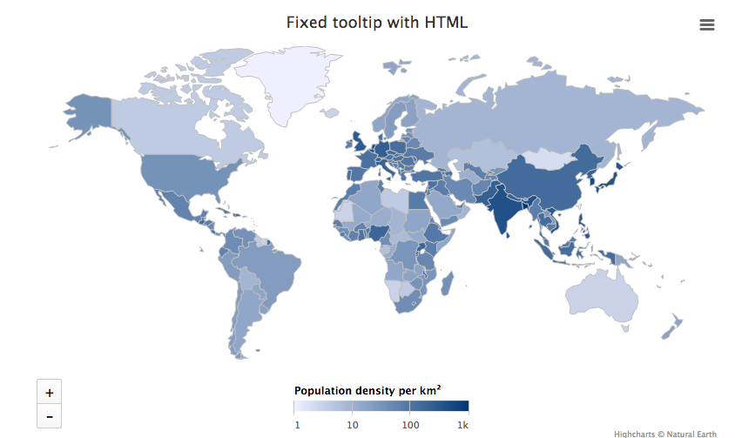

input:

?([  
 {  
 "code": "AF",  
 "value": 53,  
 "name": "Afghanistan"  
 },  
 {  
 "code": "AL",  
 "value": 117,  
 "name": "Albania"  
 },

* { “code”: mapecode,

“code”:value from twitts,

“name”:country’s name

}

link:

http://www.highcharts.com/samples/data/jsonp.php?filename=world-population-density.json&callback=?

left column: user’s history stored keyword

right column: recommend keywords

Views:

1: <http://www.highcharts.com/demo/bar-stacked>

Present the ratio of positive/nag/nu content. when the user click on the bar show the top 5 most representative tweets.

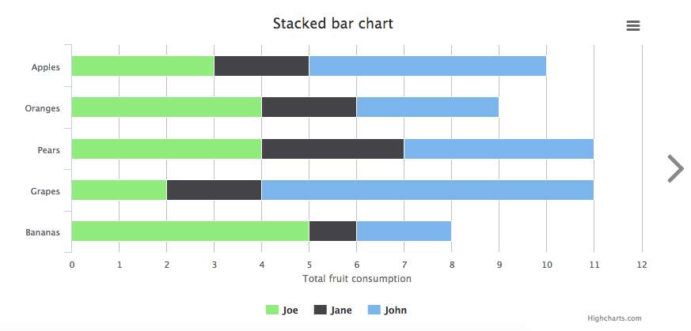

input:

xAxis: {

categories: ['Apples', 'Oranges', 'Pears', 'Grapes', 'Bananas']

* [keyword,keyword]

series: [{

name: 'John',

data: [5, 3, 4, 7, 2]

}, {

name: 'Jane',

data: [2, 2, 3, 2, 1]

}, {

name: 'Joe',

data: [3, 4, 4, 2, 5]

}]

* we can change John,Jane,Joe to Positive/Negative/Nature.

2:<http://www.highcharts.com/stock/demo/spline>

Average opinion of the keyword in the history(can choose different scale of time)

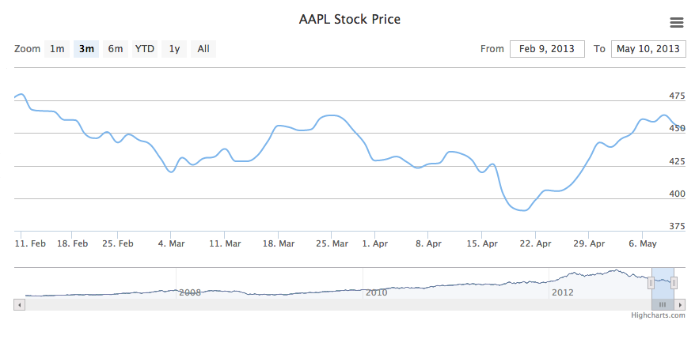

input:

link: http://www.highcharts.com/samples/data/jsonp.php?filename=aapl-c.json&callback=?

?(/\* AAPL historical OHLC data from the Google Finance API \*/  
[  
/\* May 2006 \*/  
[1147651200000,67.79],  
[1147737600000,64.98],  
[1147824000000,65.26],  
[1147910400000,63.18],  
[1147996800000,64.51],  
[1148256000000,63.38],  
[1148342400000,63.15],  
[1148428800000,63.34],  
[1148515200000,64.33],  
[1148601600000,63.55],  
[1148947200000,61.22],  
[1149033600000,59.77],  
/\* Jun 2006 \*/

* [position on timeline, value]

3: <http://www.highcharts.com/demo/line-labels>

Average opinion of two or more keyword in the history(can choose different scale of time)

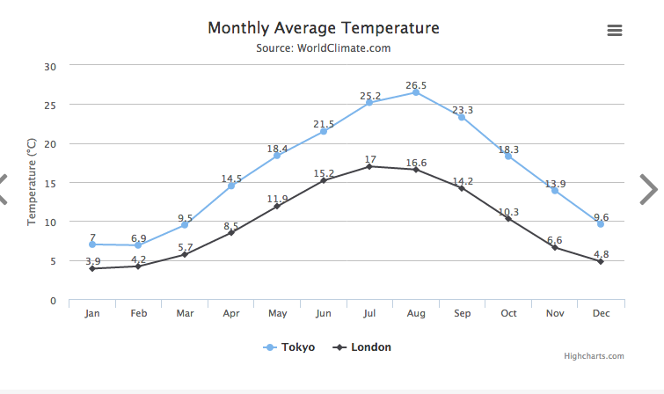

input:

xAxis: {

categories: ['Jan', 'Feb', 'Mar', 'Apr', 'May', 'Jun', 'Jul', 'Aug', 'Sep', 'Oct', 'Nov', 'Dec']

},

yAxis: {

title: {

text: 'Temperature (°C)'

}

},

series: [{

name: 'Tokyo',

data: [7.0, 6.9, 9.5, 14.5, 18.4, 21.5, 25.2, 26.5, 23.3, 18.3, 13.9, 9.6]

}, {

name: 'London',

data: [3.9, 4.2, 5.7, 8.5, 11.9, 15.2, 17.0, 16.6, 14.2, 10.3, 6.6, 4.8]

}]

4: research

input: top 20 most frequently mentioned words related to the searched keywords



more research:

input keyword <http://www.jasondavies.com/wordcloud/#>

sorted bar <http://bl.ocks.org/mbostock/3885705>

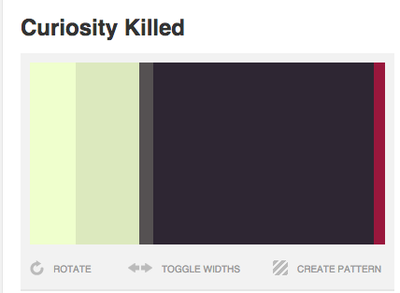

2

<http://www.colourlovers.com/palette/953498/Headache>

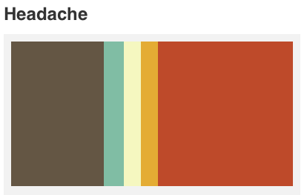

2

<http://www.colourlovers.com/palette/540619/Funny_Like_the_Moon>

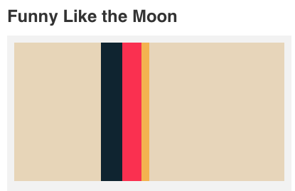

<http://www.colourlovers.com/palette/482774/dream_magnet>

3

Font pick:

<http://www.dafont.com/roboto.font>

<http://www.dafont.com/code.font>

<http://www.google.com/fonts/specimen/Poiret+One>

<http://www.dafont.com/walkway.font>

<http://www.dafont.com/cafe-brewery.font>

<http://www.dafont.com/aubrey.font>

<http://www.dafont.com/vanadine.font>